YES, to Affordable Housing for Cambridge
NO, to the City of Cambridge’s 100% Affordable Housing Overlay*
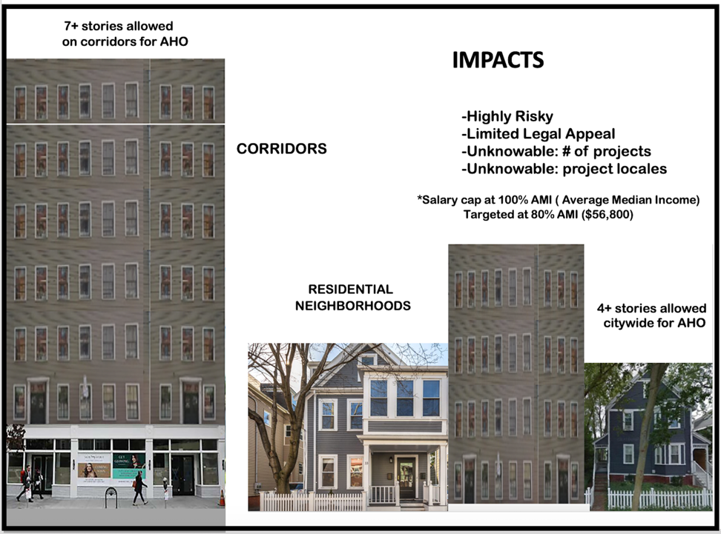
This could happen in every neighborhood!

          - Allows for the removal of mature trees and green spaces
          - Allows residential tear-downs & renter displacement
          - Allows 2 to 8 times denser housing
          - Promotes tall, wide, box-like 4-5 story buildings citywide
          - Allows tall, wide, box-like 7 story buildings on major corridors
          - Changes design standards and diminishes over-sight
          - Restricts citizen rights to legal appeal
          - May encourage the closing of local businesses
          - Will add to traffic congestion by increasing density, reducing parking
          - Alters city livability, neighborhood distinctiveness, and quality of life

Tell City Councilors that you will not vote for them if they don’t oppose the AHO!

Email: council@cambridgema.gov and CC the Clerk: pcrane@cambridgema.gov
Get Involved: Join our effort at Cambridge Citizens Coalition https://www.cccoalition.org
We are Cambridge residents who support smart, responsible growth, affordable housing,
sustainability, preservation of our environment and enduring importance of our architectural legacy.

*Affordable Housing Citywide Overlay Zoning Proposal (AHO):
https://www.cambridgema.gov/CDD/Projects/Housing/affordablehousingoverlay

