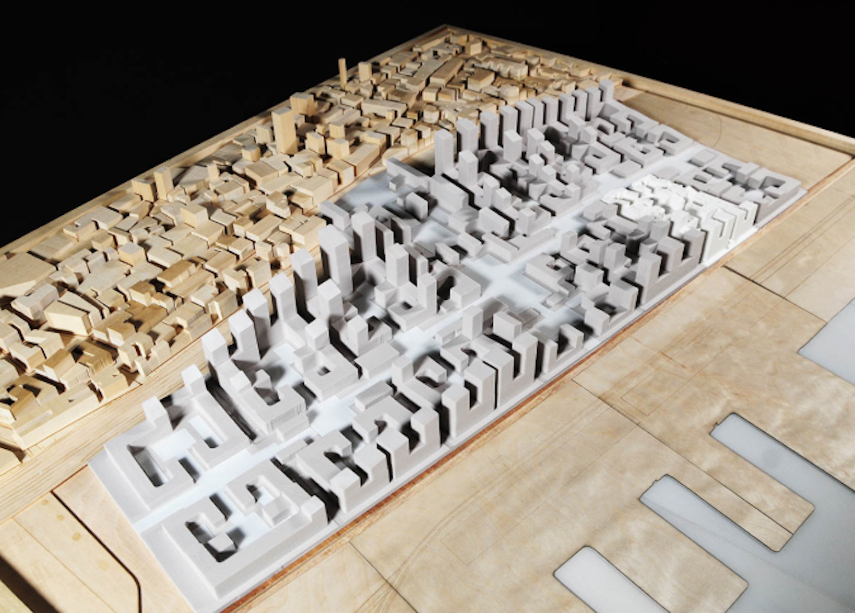
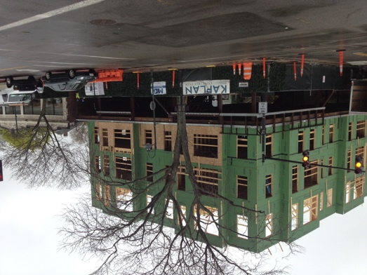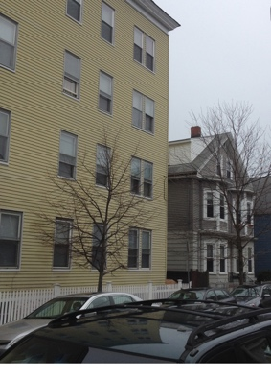

4 story buildings to become 7 story 4 story next to a 2 story Form-Built added density

FAQ Sheet on the city-wide Up-Zoning Overlay Proposal on 100% Affordable Housing
The proposed city-wide 100% Affordable Housing Overlay (AHO) will:
- Allow 4 story buildings (45’ in all city residential areas for affordable housing projects. N.B. a triple decker is typically 32’ high including a 4' foundation above grade; allow 50’ with active 1st floor commercial or related use). 5 stories are allowed for an active first floor (e.g.store fronts).
- Allow 80’ (7plus stories) on all “major transit corridors” (Ma. Ave., Mt. Auburn, Concord, Cambridge St. etc.) – including areas of 2-3 story buildings now.
- Change zoning and design review criteria from the current FAR (floor area ratio) calculations to fixed height (e.g. 4 or 7 stories) and fixed property-line set backs (e.g. 7.5 feet from side boundary). This will increase density -as currently measured in FAR- by a factor of five to ten.
- Limit city-wide fixed property line set-backs to 7.5 feet on each side of the building; 10 feet in front; 20 feet in back on affordable housing projects.
- Excludes property open space from dimensional and other requirements; includes no green space requirement and limits current open space requirements. While some city areas have parks and little residential open space; for other parts of the city it is the reverse.
- Define all affordable housing projects “as-of-right,” thereby severely limiting the ability of residents to appeal and their ability to insist on appropriate design changes to a project, giving developers a free-hand without current checks and balances.
- Transfer Final design decisions from the citizen-based Planning Board (which adjudicates with resident input) to the unelected city manager and staff for all city affordable housing projects.
- End zoning for exclusively single-family dwellings to allow multiple family residences, town houses, and apartment buildings for affordable housing projects. Home owners here will be precluded from making additions other than allowed in single-family zoning. This is inequitable and several attorneys point out that it may violate state law Section 4: Uniform districts.
- Allow each new affordable housing project to become part of the local neighborhood “context” around which all future building designs will be assessed for design appropriateness.
- Include deed-written requirement for each unit to be affordable housing (in perpetuity). The number of such projects will increase each year (the c.100 units of year one could become 7,000 units by year 70). It will preclude this private property being purchased and reused for other needs such as a school, library, grocery. This will make future city planning more difficult.
- Will be based on an economically separated public housing model (for those below 100% of Area Median Income, and targeted at 80% AMI or $56,800 per year for 1 person), rather than including a balance of low Income, median-income, and market-rate. Economically separated housing is now rejected in many communities for not being inclusive or equity-based. This also prohibits inhabitants taking new higher paying jobs if they want to remain in their units and provides no avenue to home ownership for residents (who meet criteria) to purchase their units to resell to the city for ongoing affordable housing once they leave.

