HOUSECONCERT in Cambridge with AMY SPEACE!
Angel Snow opens February 16th 7:00 PM
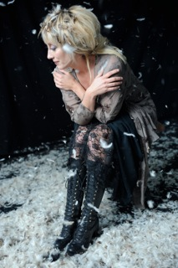
Private RESIDENCE in CAMBRIDGE (near Porter Square)
RSVP: rryals@comcast.net (617) 547-6453
Suggested donation at the door: $20/$35-couple
After releasing two well-received albums on Judy Collins’ Wildflower Records, Land Like A Bird is Amy Speace’s first album since migrating south from her longtime home in the NYC area.
Speace's path to songwriting has not been a straight line. Like many journeys, it’s been improved by the winding way. Born in Baltimore, Speace grew up the oldest of four, moved homes and states every few years, learned early about comings and goings, and found solace in music.
After graduating from Amherst College, she moved to Manhattan to study acting. She toured with The National Shakespeare Company until a bad breakup and a $50 pawn shop guitar sparked a late-blooming songwriting burst. An appearance at an open mic led to a regular gig at The Bitter End. This in turn, led her first recorded songs. In 2005, a chance encounter with Judy Collins' manager changed Speace’s life. Speace signed with Judy Collin’s company, Wildflower Records, which released Songs for Bright Street.
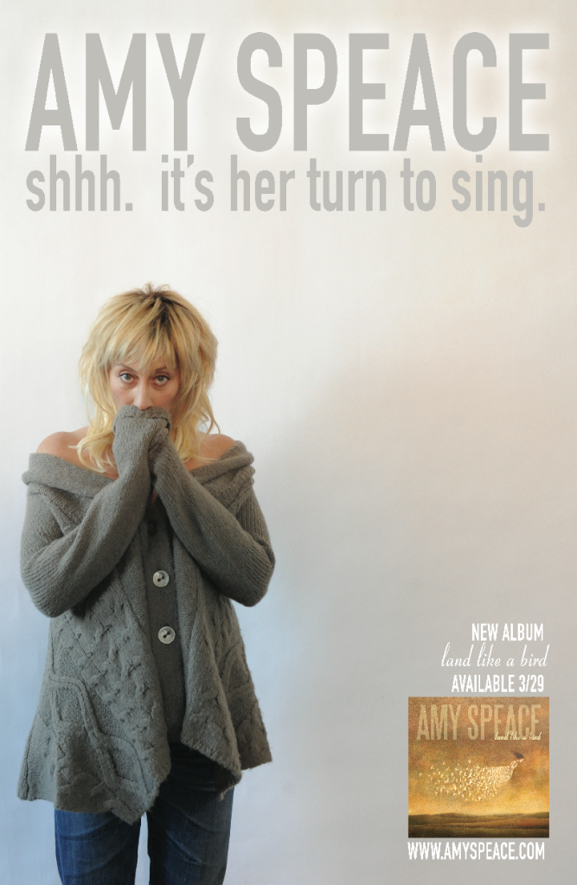
The Killer In Me followed in 2009, with a duo appearance by Ian “Mott the Hoople” Hunter, who brought Speace to the UK for his Acoustic Tour. USA Today called her “a rising star.” NPR said “her velvety, achy voice recalls an early Lucinda Williams.” and named the title track from Killer its Song of the Day.
John Platt of NYC's premiere AAA radio station WFUV placed Speace’s song, “The Weight of the World,” in his Top 5 List of Best Folk Songs of the Decade. Later, Judy Collins recorded this song and called it “one of the best political folk songs I've ever heard”.
In 2009, Amy shifted landscapes, moved south to Nashville, and created her latest album Land Like A Bird. Produced by Neilson Hubbard, it features guest vocals by Kim Richey. This album has received the best reviews of Amy's career.
Amy will also be seen in the upcoming documentary “Nothing Can Hurt Me: The Big Star Story”.

